**CS6110 - Object Orientated Analysis and Design**

**SOCIAL NETWORKING SITE**

**Team Members**

|  |  |
| --- | --- |
| **Srivatsav R** | **2019103066** |
| **Sachin Raghul T** | **2019103573** |
| **Sanjeev KM** | **2019103576** |

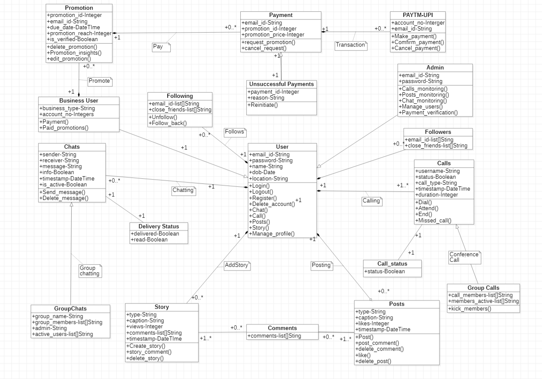**Refined Class Diagram :-**

**Conceptual class hierarchies**

|  |  |
| --- | --- |
| Conceptual class hierarchies | |
| Super Class | **Subclass** |
| User | User |
| Business User |
| Admin |
| Chat | Group Chat |
| Calls | Conference Call |
| Payment | Unsuccessful |

**Aggregate Relationships**

|  |  |
| --- | --- |
| Conceptual class hierarchies | |
| Status | User |

**Association**

|  |  |  |
| --- | --- | --- |
| Conceptual class hierarchies | | |
| Class 1 | **Role** | **Class 2** |
| Calls | check | Call_Status |
| Payments | verify | Unsuccessful_payment |
| Business User | Promotion | Promotions |

**Composition relationship:**

|  |  |
| --- | --- |
| Composition relationship | |
| Class of components | **Class of composites** |
| Users | Business User |
| Admin |
| Chats | Users |
| Calls |
| Posts |
| Status |
| Promotion |